

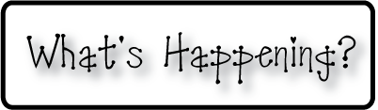

**Friday-Spelling test!!!!!!!**

**Thursday**-spelling word practice

Daily language practice

Spelling test tomorrow!!!!

**Wednesday-** spelling word practice

Daily language practice

**Tuesday- vowel sounds**

**Write a paragraph with sound words**

Spelling list for the week:

shall

dream

aid

tease

squeak

spent

desk

least

plant

stack

grace

shade

*mascot

**Monday- Worked on Vowel sounds, writing – begin a story with a sound.**



**Daily notes from Mrs. Osborn’s Room**

**http://osbornsunrise.weebly.com**

**Week 1/27 – 1/31**